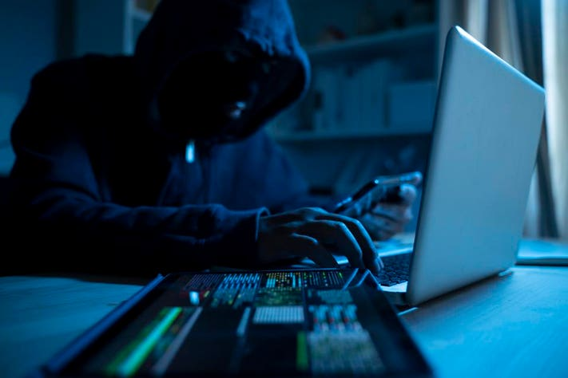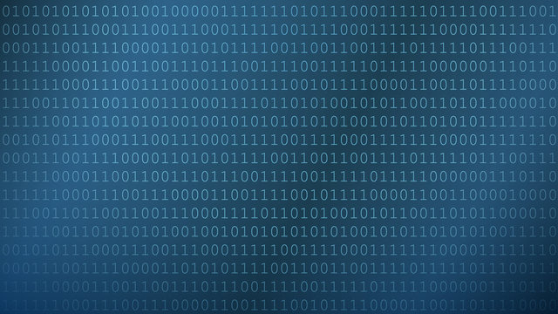

In the digital underworld, organized crime isn't just a network—it's a symphony of code, orchestrating chaos in the shadows of cyberspace.

Michael Amoo